SEATARA

WHEELABLE

User Manual
V. 1.0 2015

TABLE OF CONTENTS
General 3
Introduction 3
Intended use 3
EXPECTED Lifetime 3
warranty 3
Spare parts orders, complaints 3
Safety 4
Intended use 4
Warnings 4
Danger of slipping! 4
Danger of tipping over! 4
Danger of breakage! 4
Danger of falling! 5
Danger of pinching! 5
Symbol advisories 6
Product specifications 7
Dimensions 7
Scope of delivery 7
Technical specifications 8
Assembly 9
Folding 14
Cleaning and maintenance 18
Warranty 19
Warnings for use 20
User Questionnaire 21

- Please read this user manual before using the commode and shower chair for the first time, and keep it at hand for future reference.

General

Introduction
In this user manual you will find information and advice for using, operating and maintaining the commode and shower chair.

Intended use
The commode and shower chair is designed for homecare and out-patient purposes. The commode and shower chair is to be used exclusively for assistance during showering or bathing, using a toilet, or for transfer of persons inside buildings. The commode and shower chair is not designed for long periods of sitting.
- Store the commode and shower chair in dry conditions only!
Ambient temperature: 0 – 40°C (104°F)
Relative humidity: 30% - 70%

EXPECTED Lifetime
The expected lifetime of the commode and shower chair when properly used and maintained is up to 4 years.

warranty
There is a 2 year warranty on the commode and shower chair. The warranty is conditioned on use in accordance with the requirements outlined in this document, as well as regular maintenance. All rubber parts are excluded. Not observing the user manual instructions, improper maintenance, and unauthorized modifications to the product without the manufacturer's prior written permission will automatically result in the immediate termination of liability and void the product warranty .

Spare parts orders, complaints
To ensure delivery of correct spare part and fast processing of complaints, always provide the product name, serial number (SN) and the product’s year of manufacture when ordering spare parts and in case of complaints. You can find this information on the commode and shower chair’s nameplate.

Safety
When using the commode and shower chair, the following safety rules must be observed:

Intended use
- The commode and shower chair is intended for use in the toilet and shower and/or for passing through narrow aisles only. The commode and shower chair may not be used for any other purposes.
- The product is not intended to be an alternative for a regular commode and shower chair on a daily basis, nor for continuous seating.
- The commode and shower chair is intended for the sole use of individuals who are medically or physically in need of using it.
- The commode and shower chair is intended to be used indoors only.
- Patients who do not have complete physical control should not use the commode and shower chair unsupervised.

Warnings

Danger of slipping!
- Before using, verify that the seat is securely pressed into the seat frame.
- Always lock the wheels of the rear wheels before using the commode and shower chair, in order to prevent the commode and shower chair from rolling away.
- The user should not sit on the front edge of the seat or seat cushion. Make sure that the user sits all the way back on the seat.
- Make sure to align the footrest to 180 degrees.

Danger of tipping over!
- The commode and shower chair may be used for sitting and rolling only when the armrests are locked into position.
- Do not bump into door sills or jambs.
- Do not use on uneven surfaces
- Use the commode and shower chair only indoors, on solid, even, non-slippery surfaces.
- Do not tilt the commode and shower chair backwards.

Danger of breakage!
- Never attempt to carry or lift the commode and shower chair while a patient is sitting in it.
- The commode and shower chair is suitable only for transporting persons. Be sure to observe the maximum allowable patient body weight (specified on the nameplate)!
- If the commode and shower chair is damaged in any way such as a fall from heights or bumping into something, it is no longer suitable for use. The commode and shower chair may not be used if any external damage signs are visible such as cracks or breakage.
- If the commode and shower chair has changed shape in any significant manner it may no longer be used.

Danger of falling!
- Sitting down, standing up and moving the patient should be supervised by a qualified caregiver, as suitable for the health condition of the patient.
- Rolling the commode and shower chair on any sloped surface may be done only with the assistance of a caregiver.

Danger of pinching!
- Avoid reaching into the hinges areas to prevent body parts or objects from getting pinched.

Symbol advisories
 | "Serial Number". This symbol shall be followed by, or appear above the manufacturer's serial number.
 | "Manufacturer". This symbol shall be adjacent to the name and address of the manufacturer.
 | Symbol indicating that the device has not been sterilized.
 | "Caution! Consult accompanying documents" or "Attention! See instructions for use."
 | "Consult instructions for use or consult operating instructions"
 | The user’s weight must not exceed 100 kg
 | "Authorized Representative in the European Community". This symbol shall be adjacent to the name and address of the authorized representative in the European Community. The address is not required on an immediate container unless the immediate container is the outer container.
 | This symbol is a mandatory marking for devices entering the European market to indicate conformity with the essential health and safety requirements set out in European Directives. The symbol may be accompanied by a four-digit identification number of the notified body. The vertical dimensions may not be less than 5 mm high.
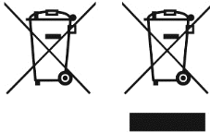 | "Not for general waste". For European Union States. This symbol should be used to mark devices that are reusable and not contaminated at the end of the device life.
 | "Keep away from sunlight"
 | The product packaging can be recycled

Product specifications

Dimensions
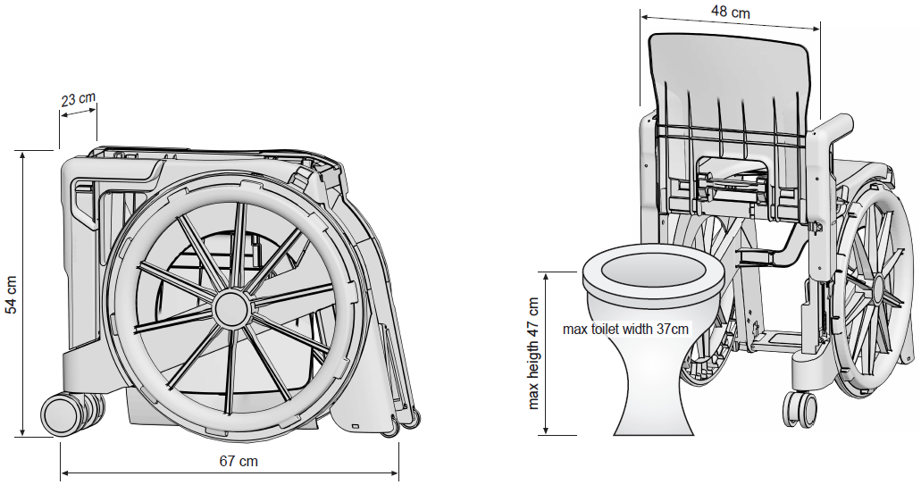

Scope of delivery
The product has been carefully inspected in the factory for defects and completeness. After you receive it, carefully check the product for possible transport damages and for completeness.

Technical specifications
We reserve the right to continue developments and making technical improvements with respect to the design shown in this user manual.
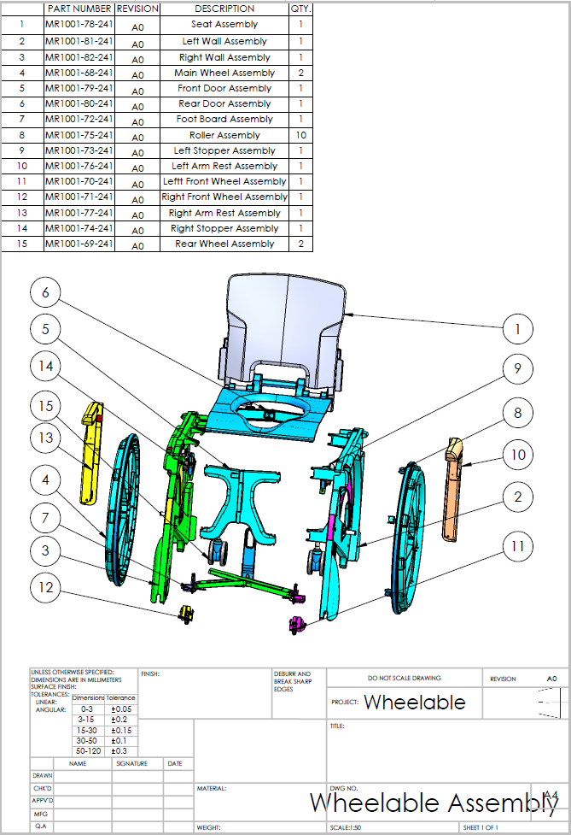

Assembly
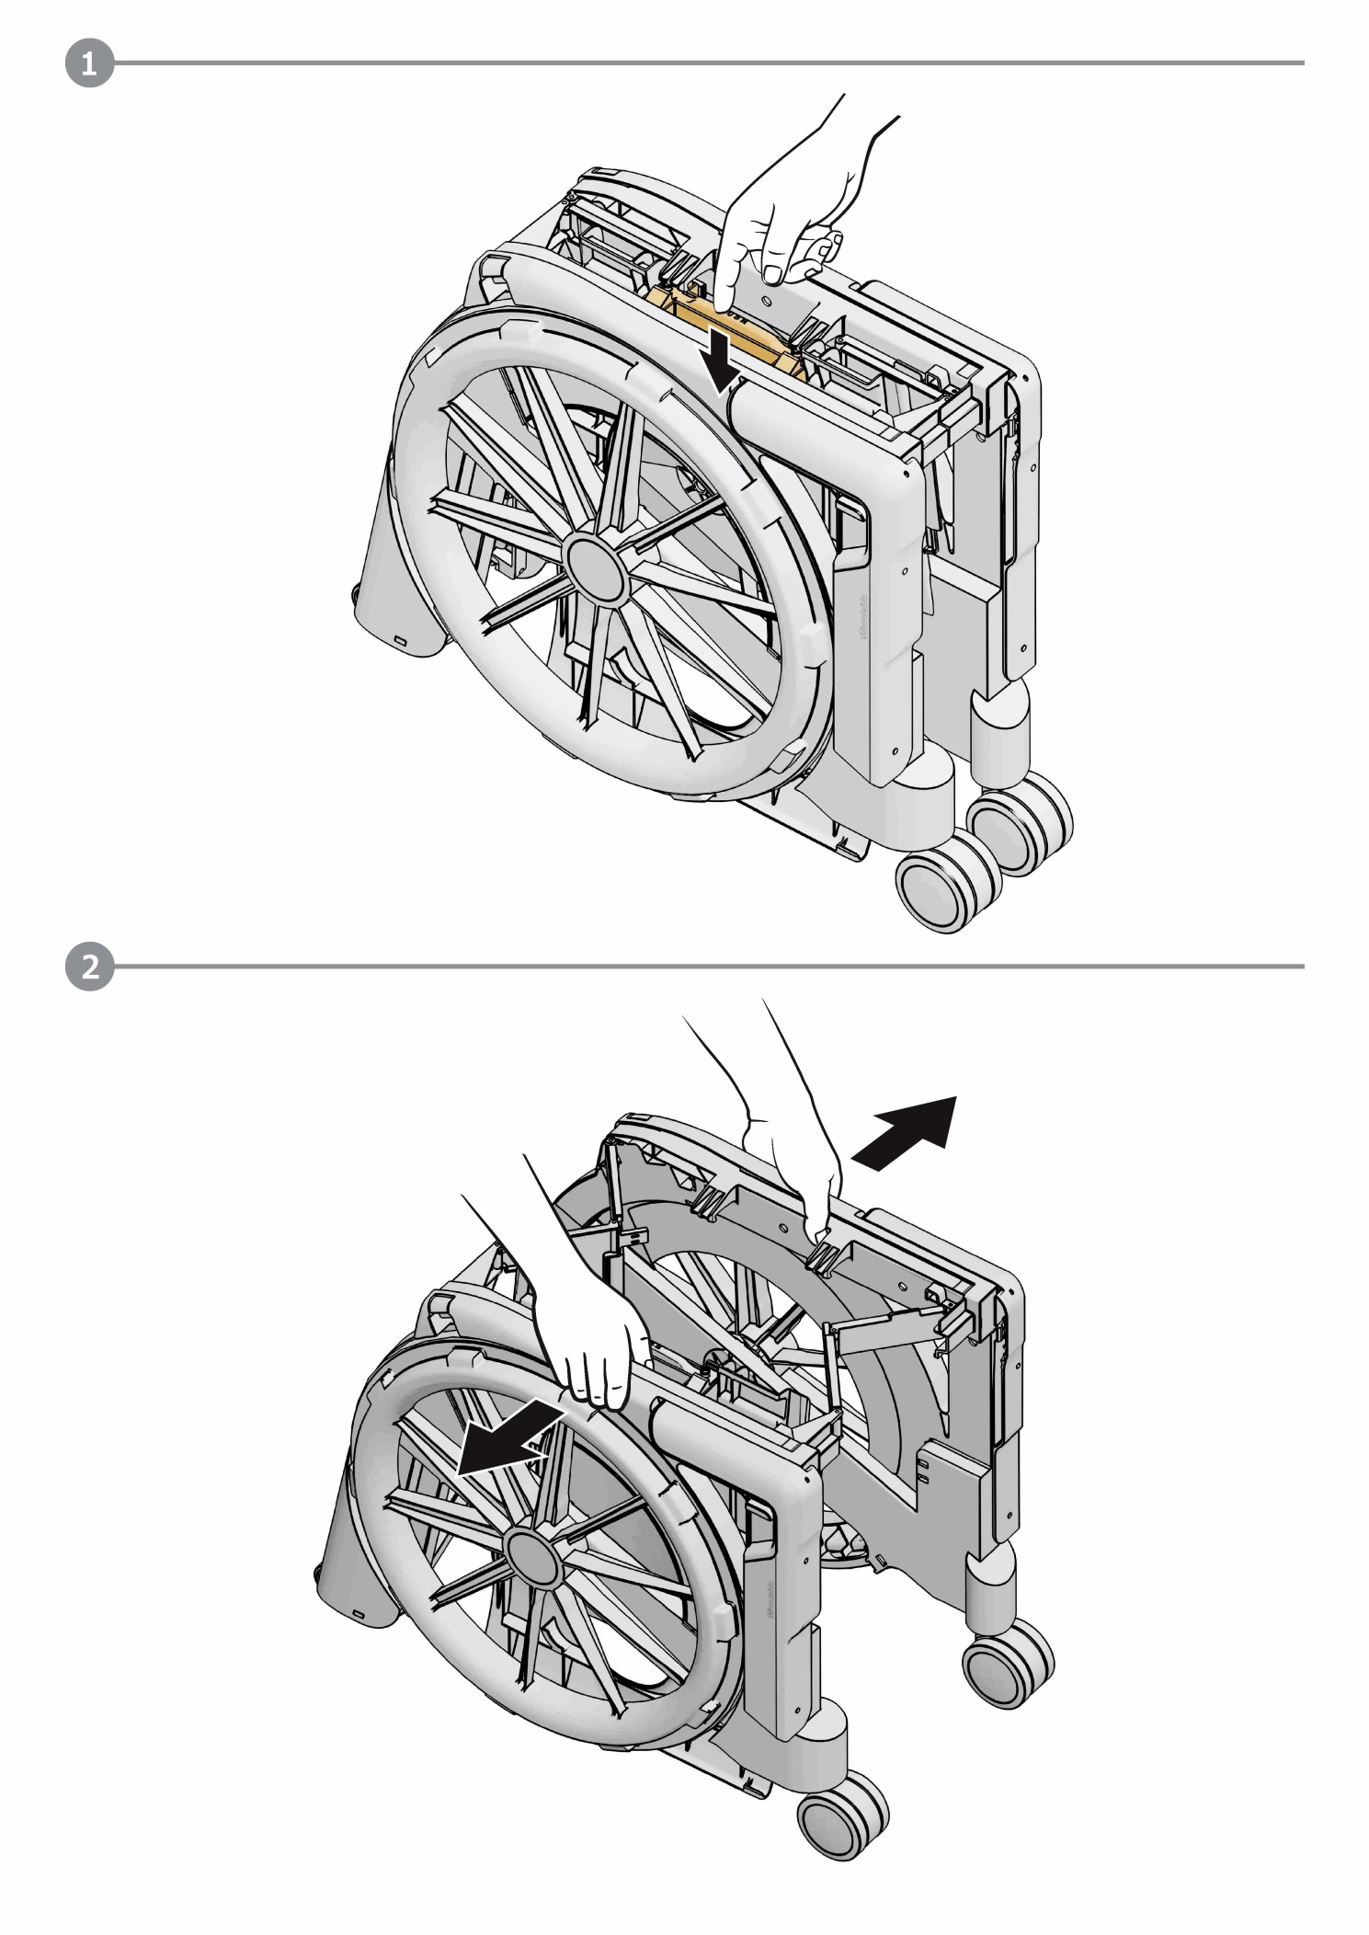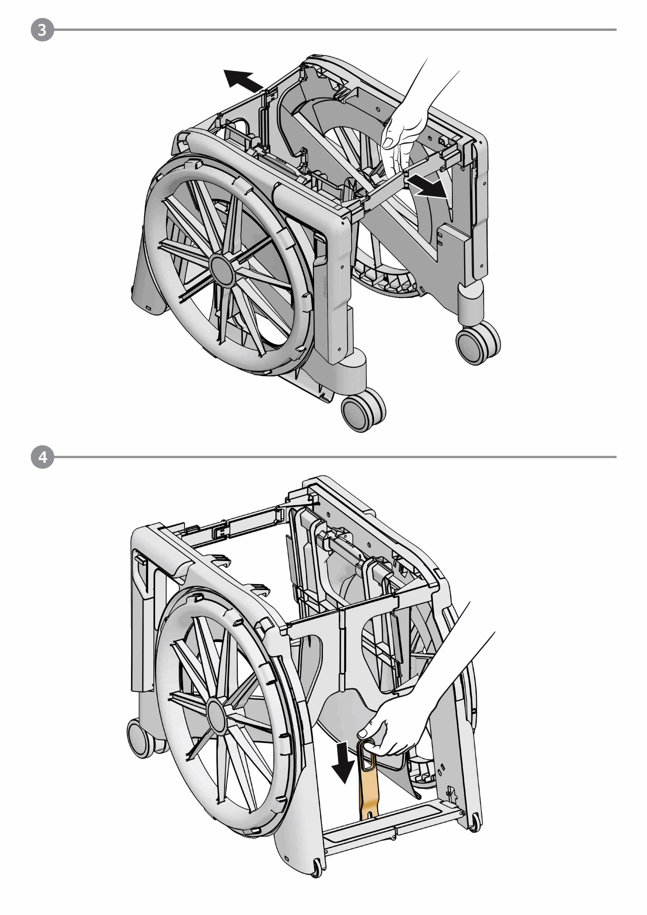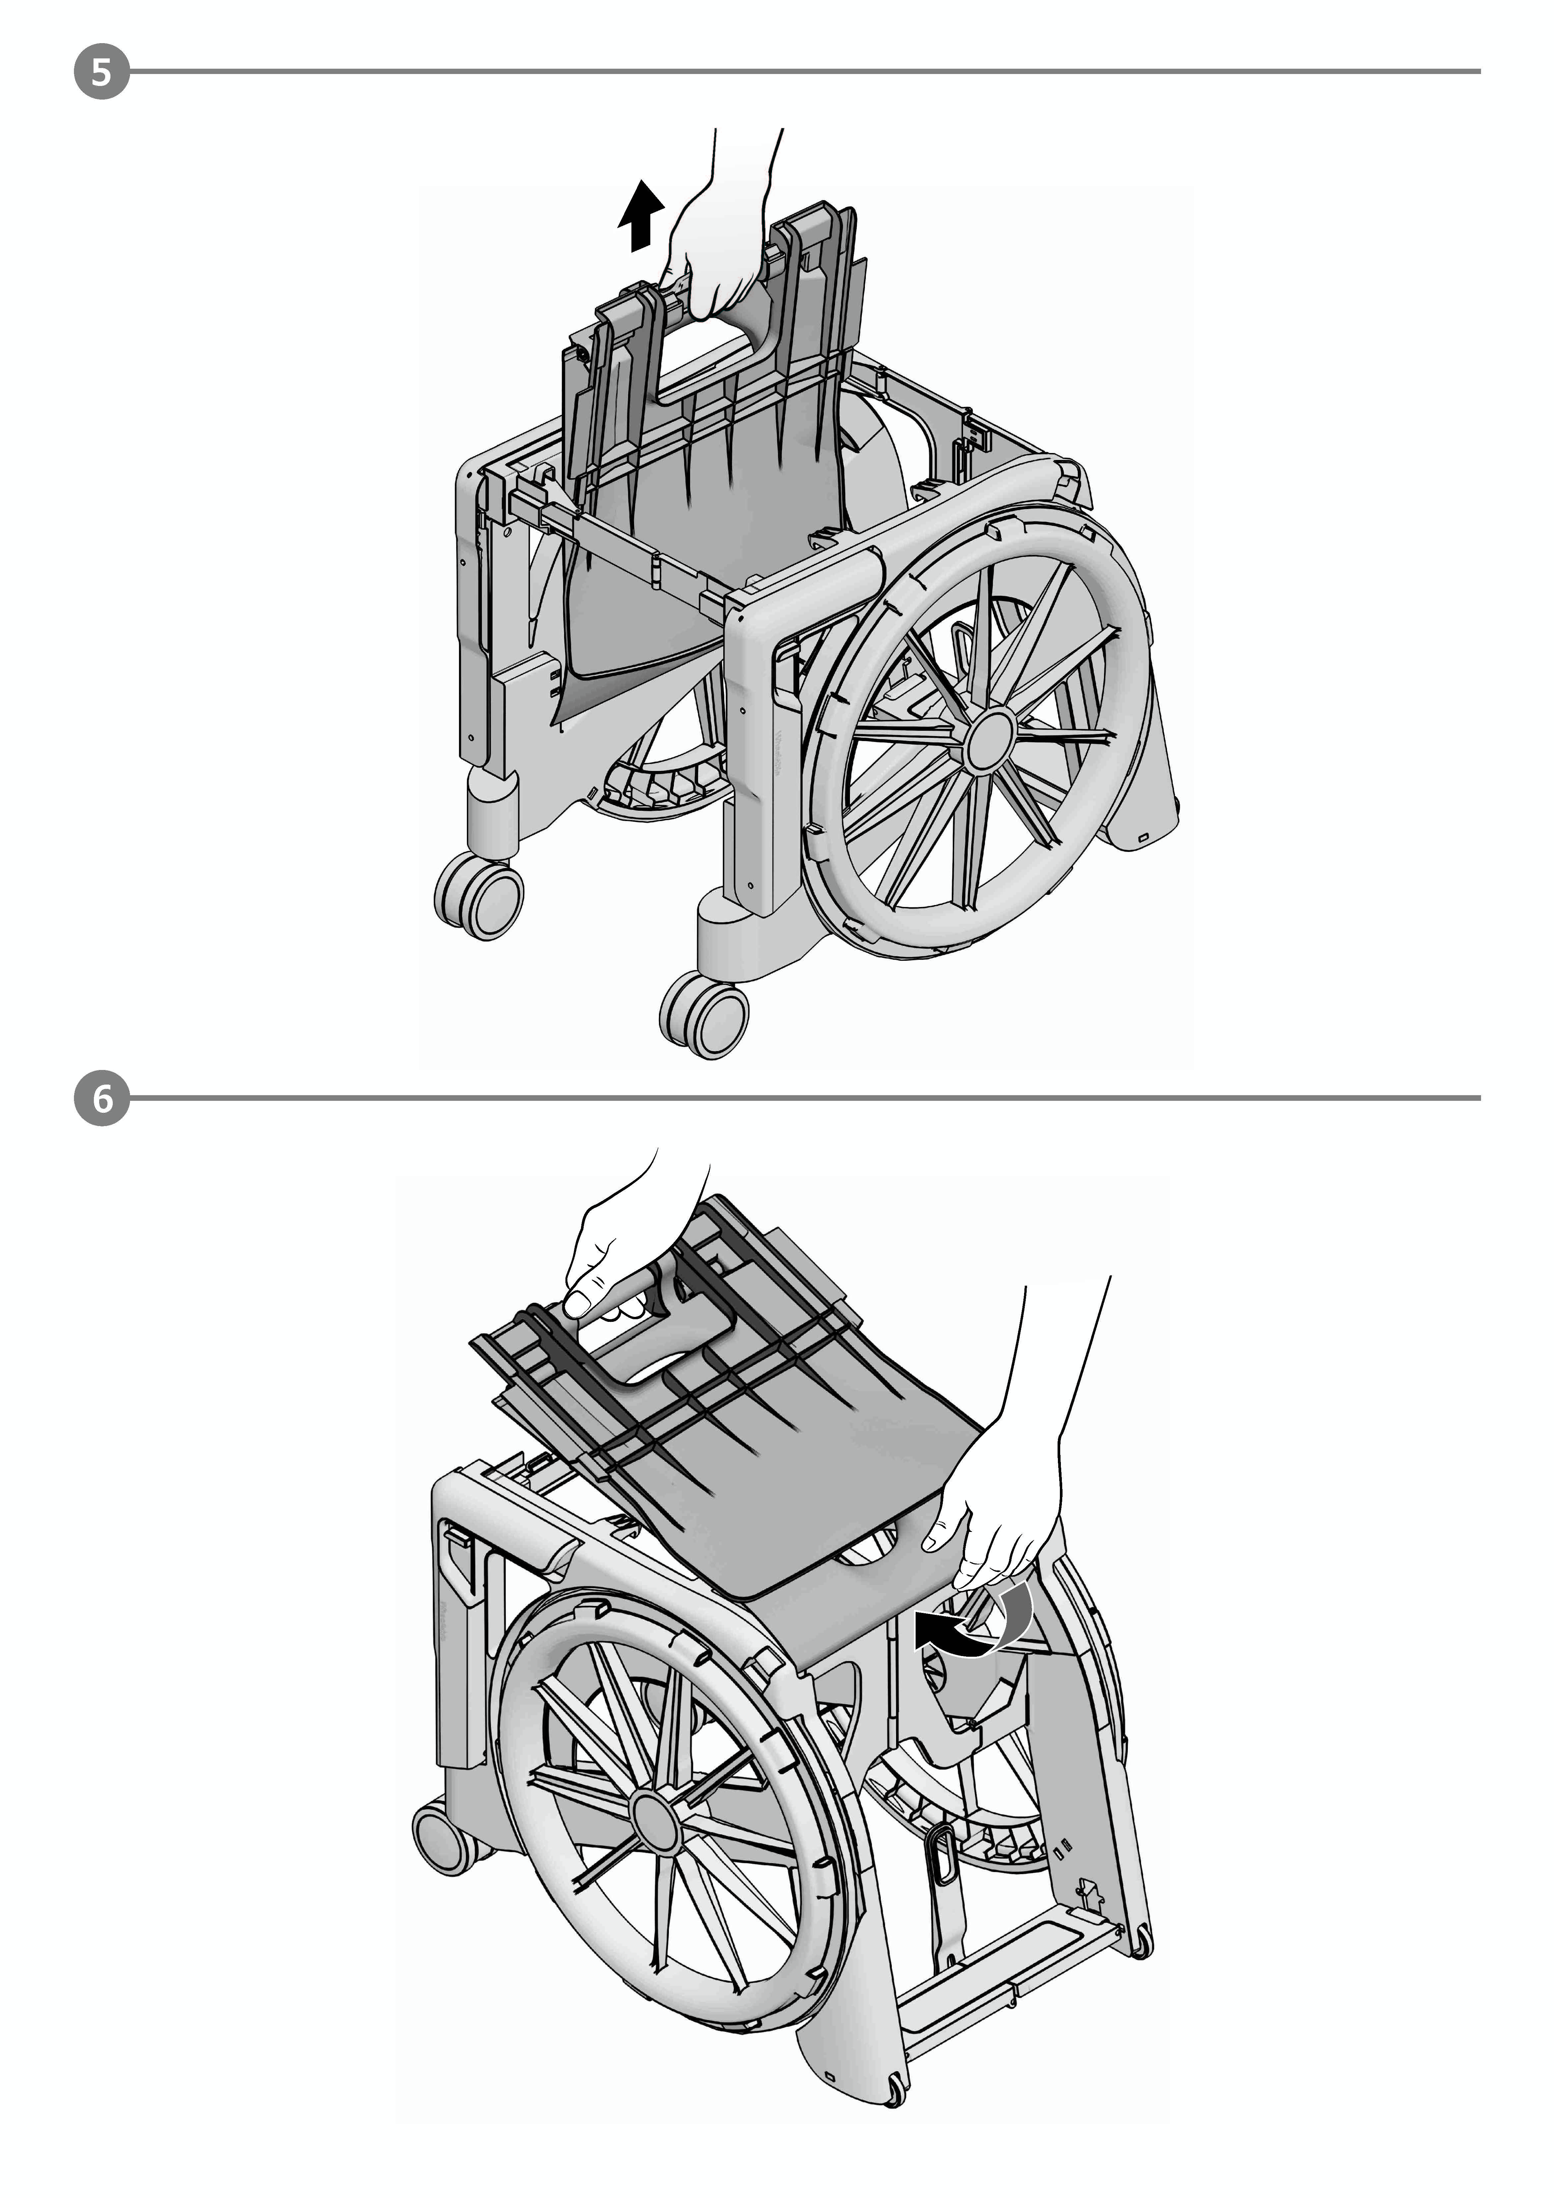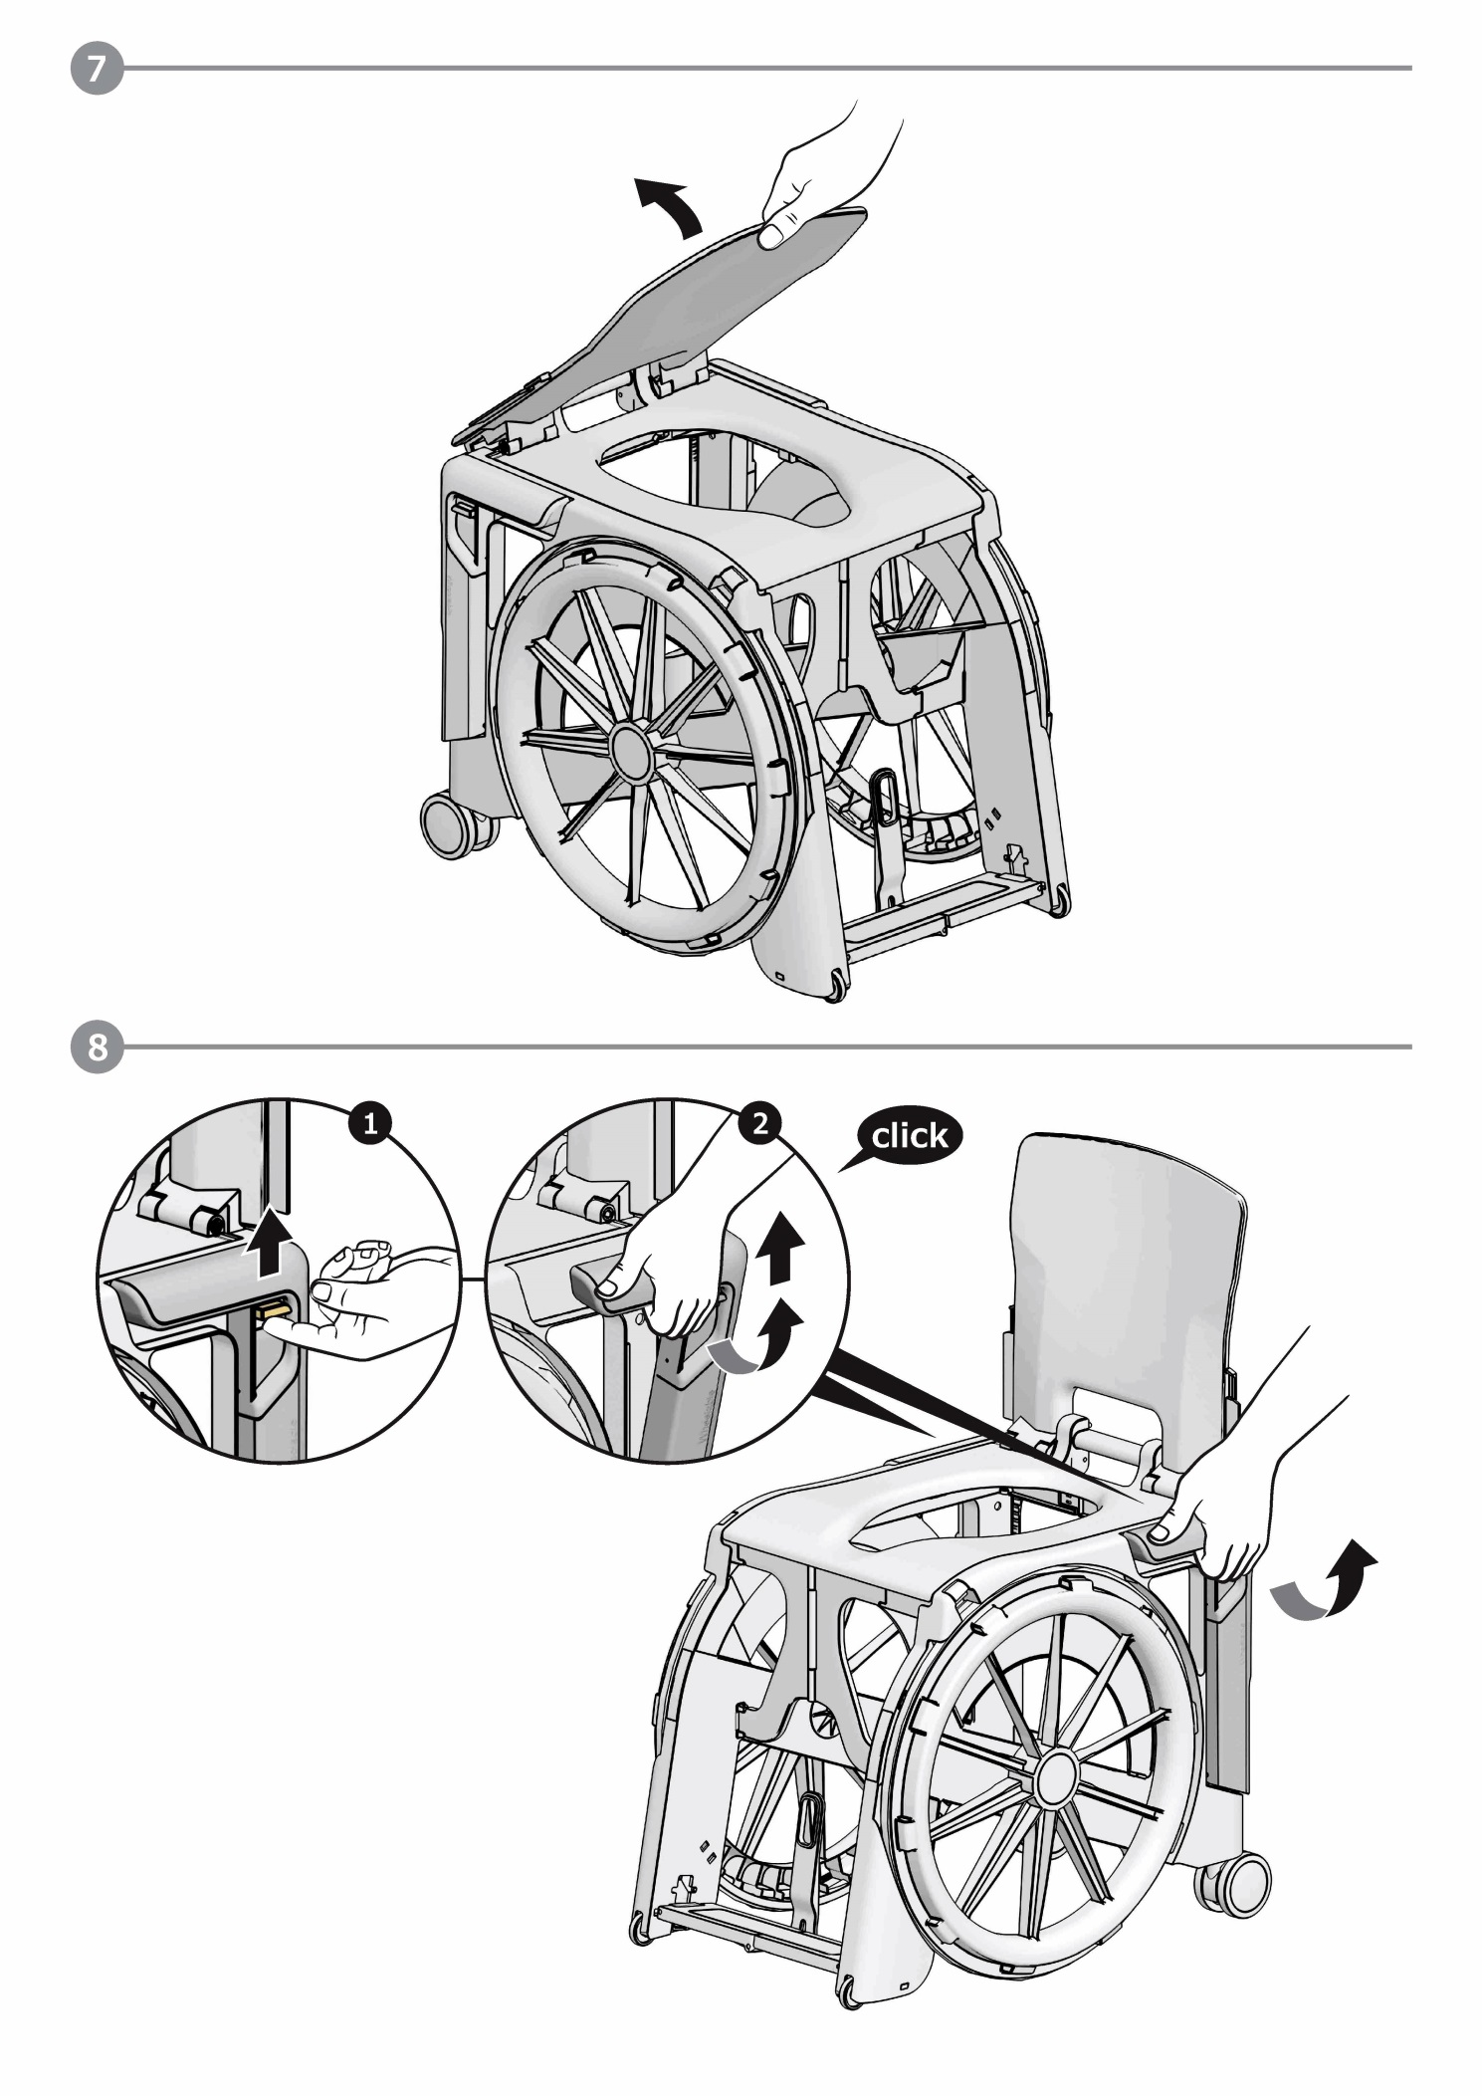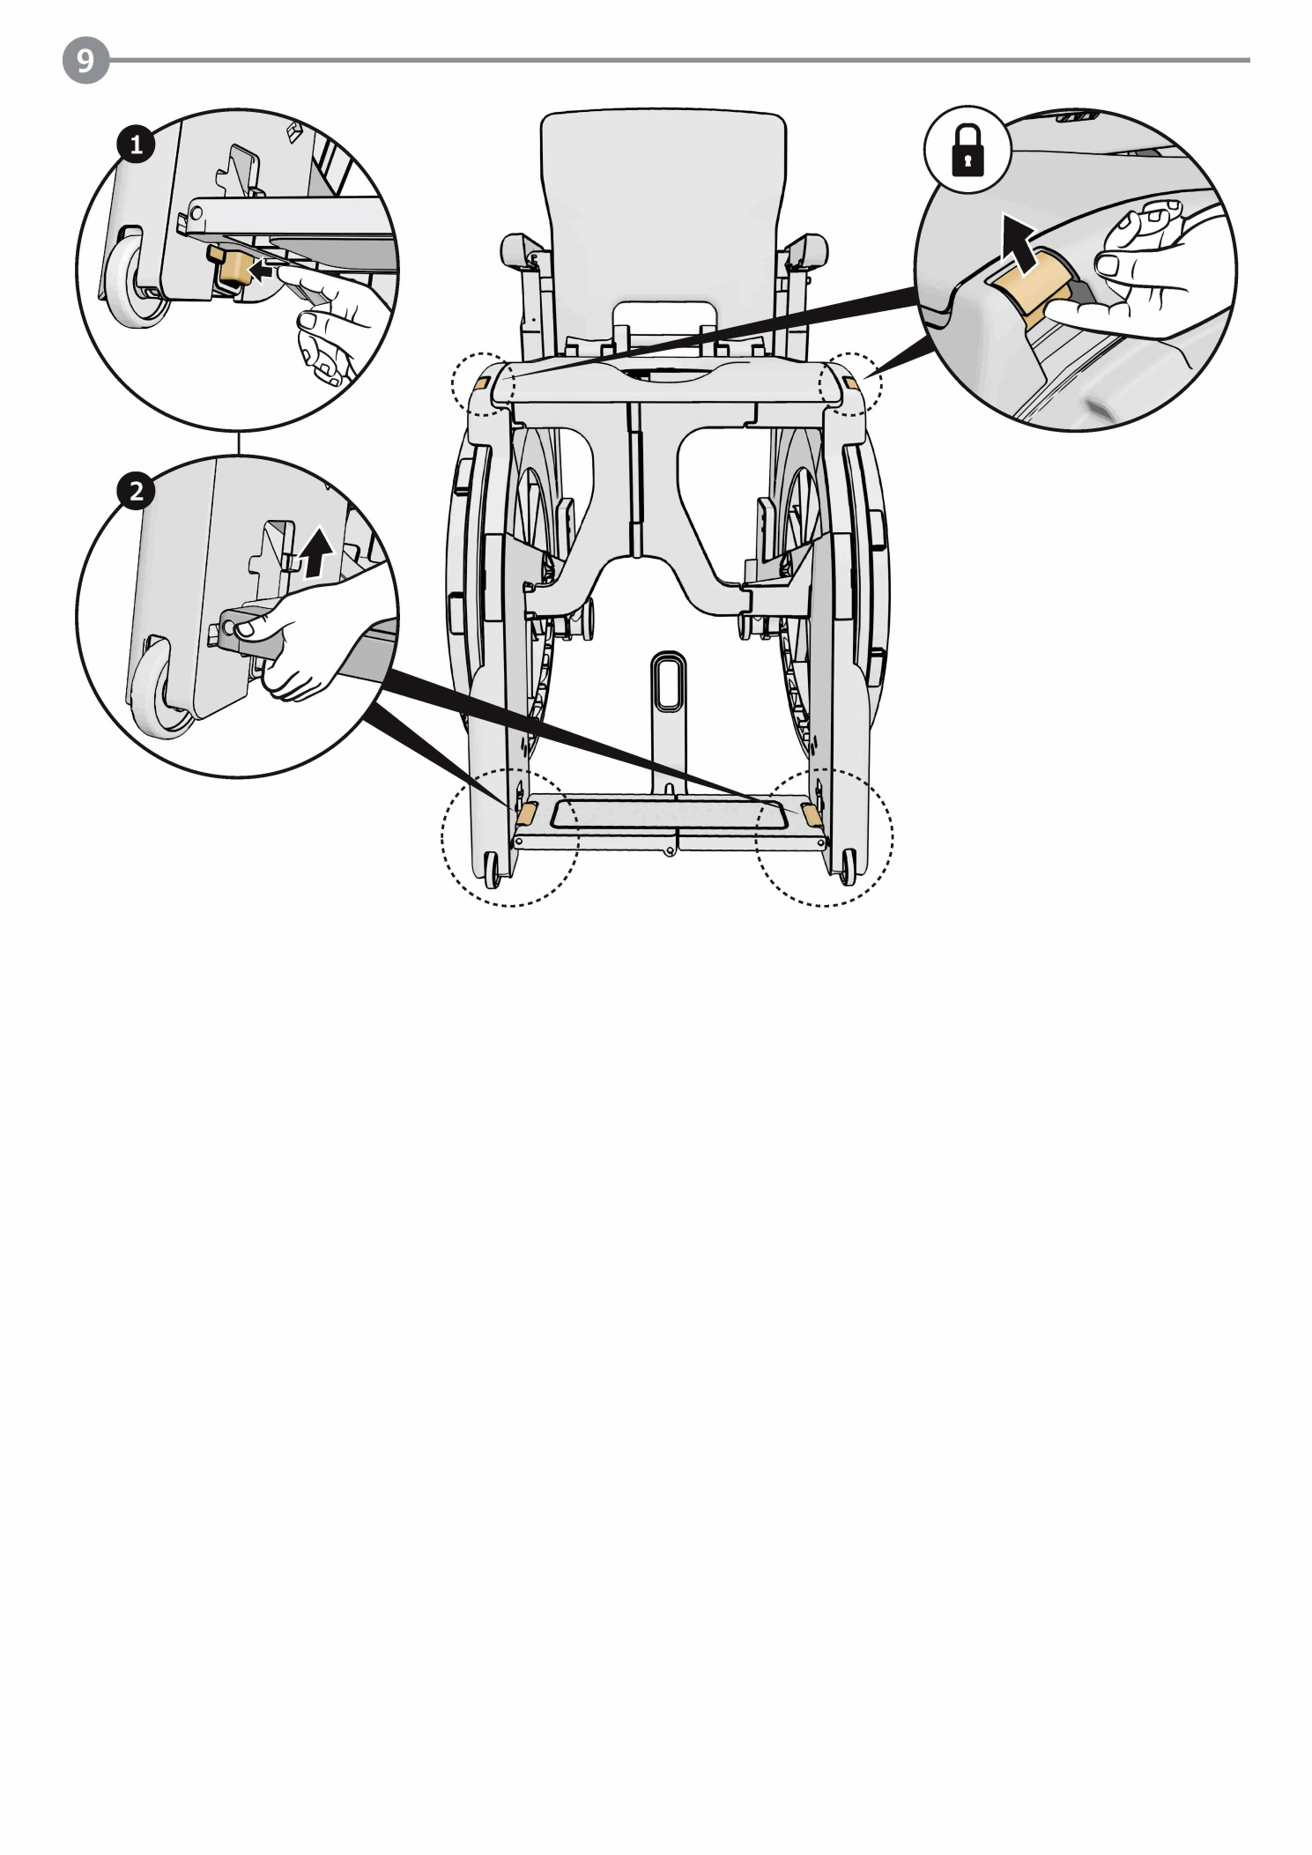

Folding
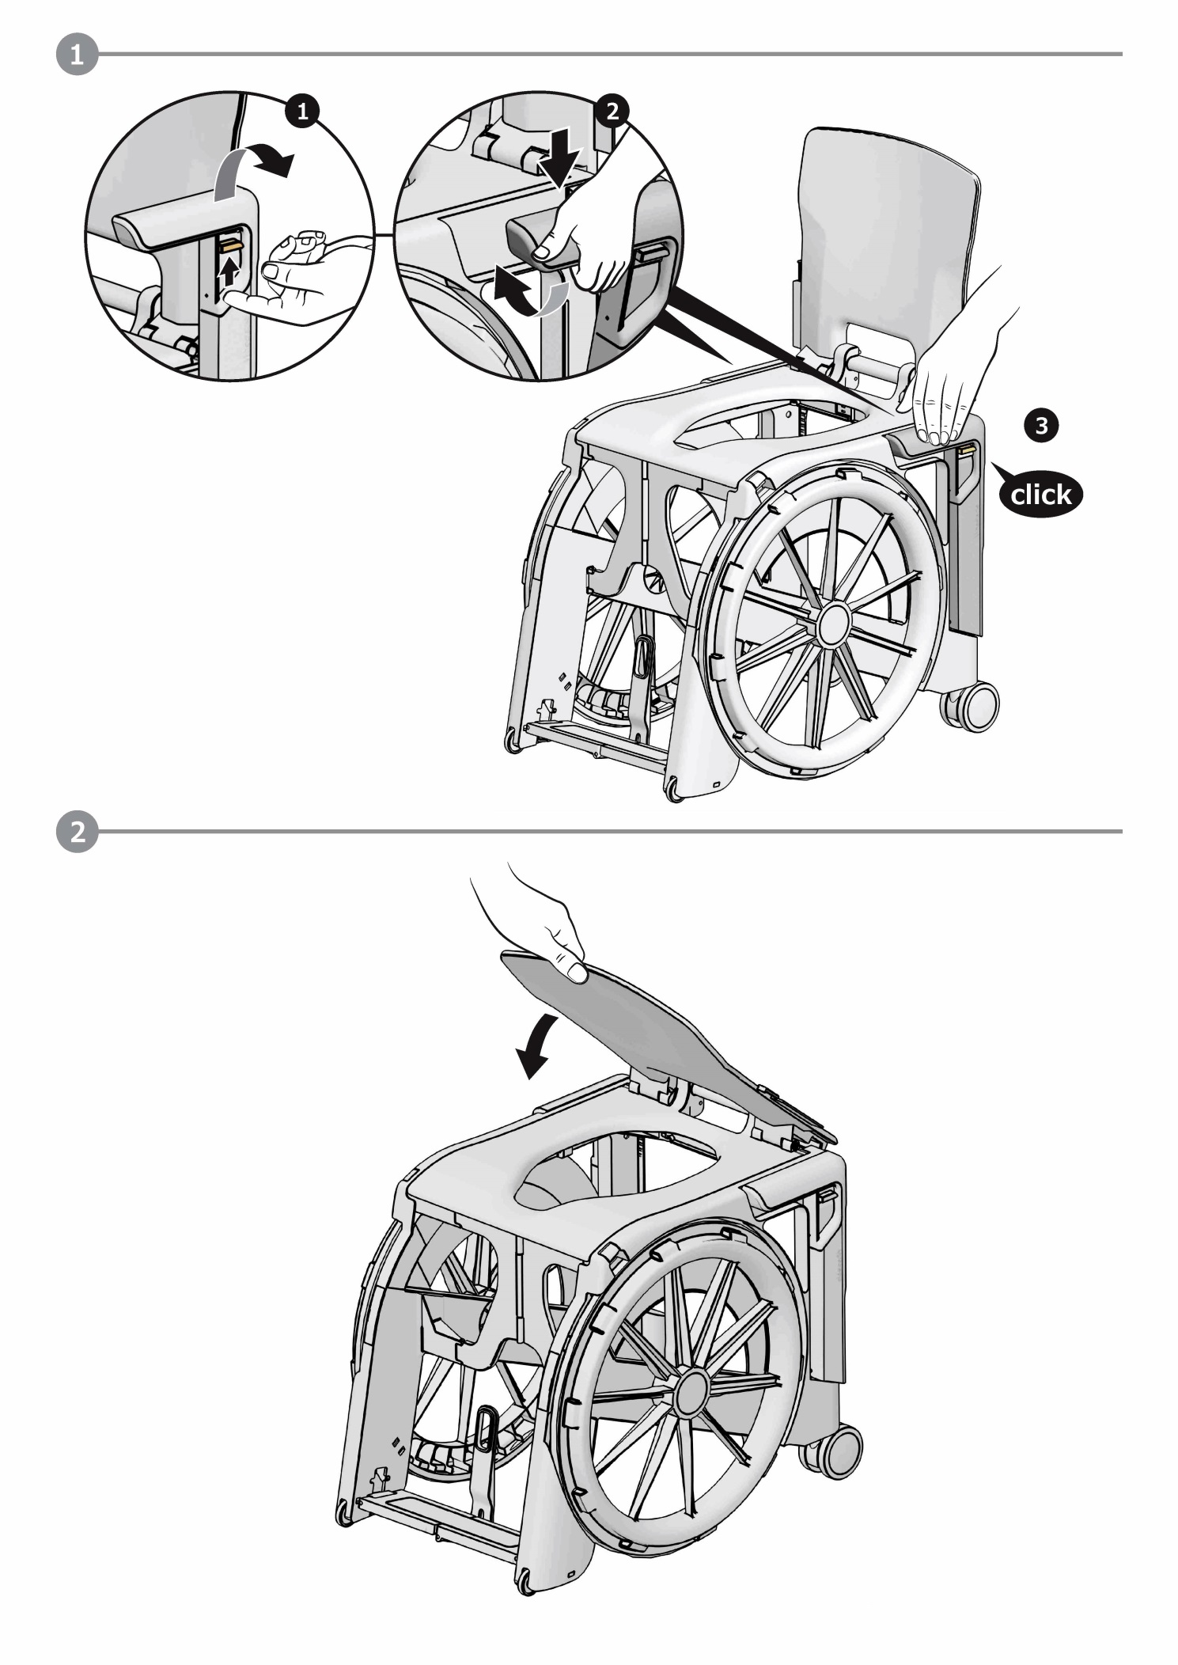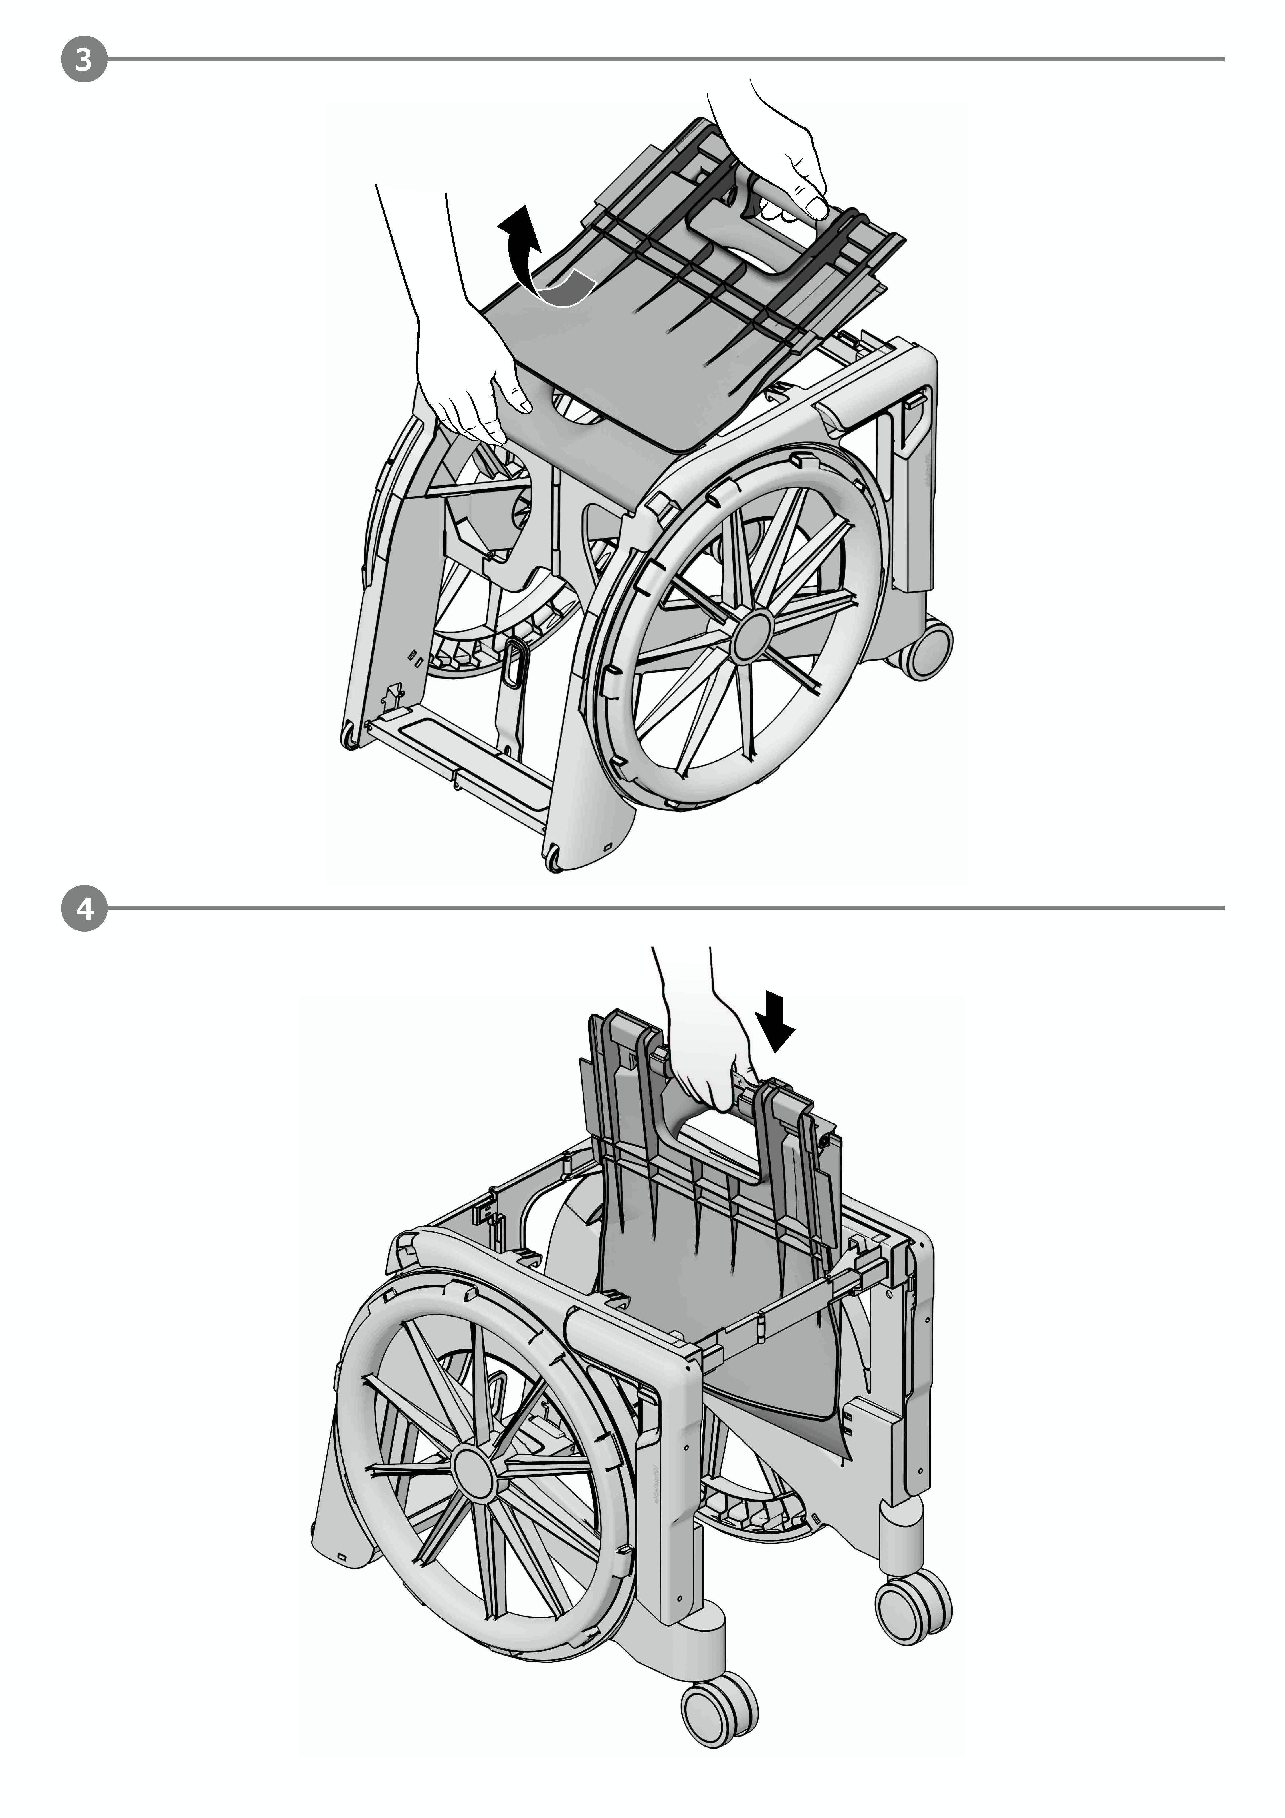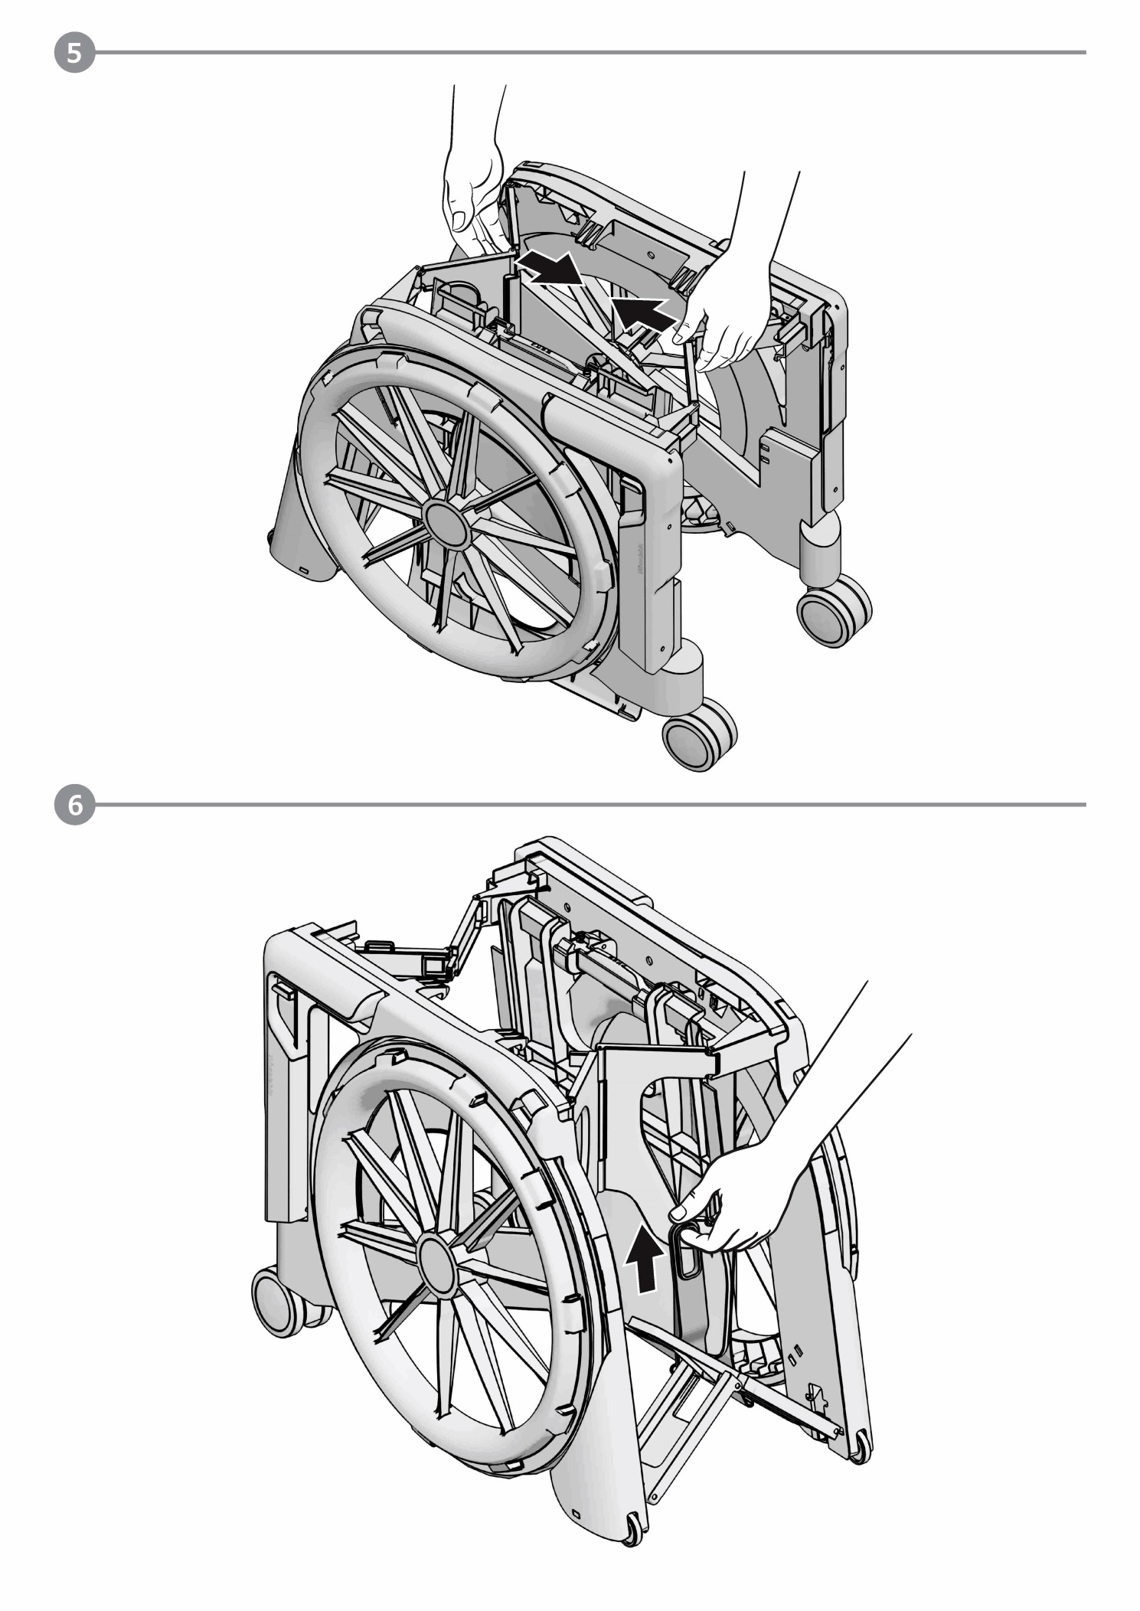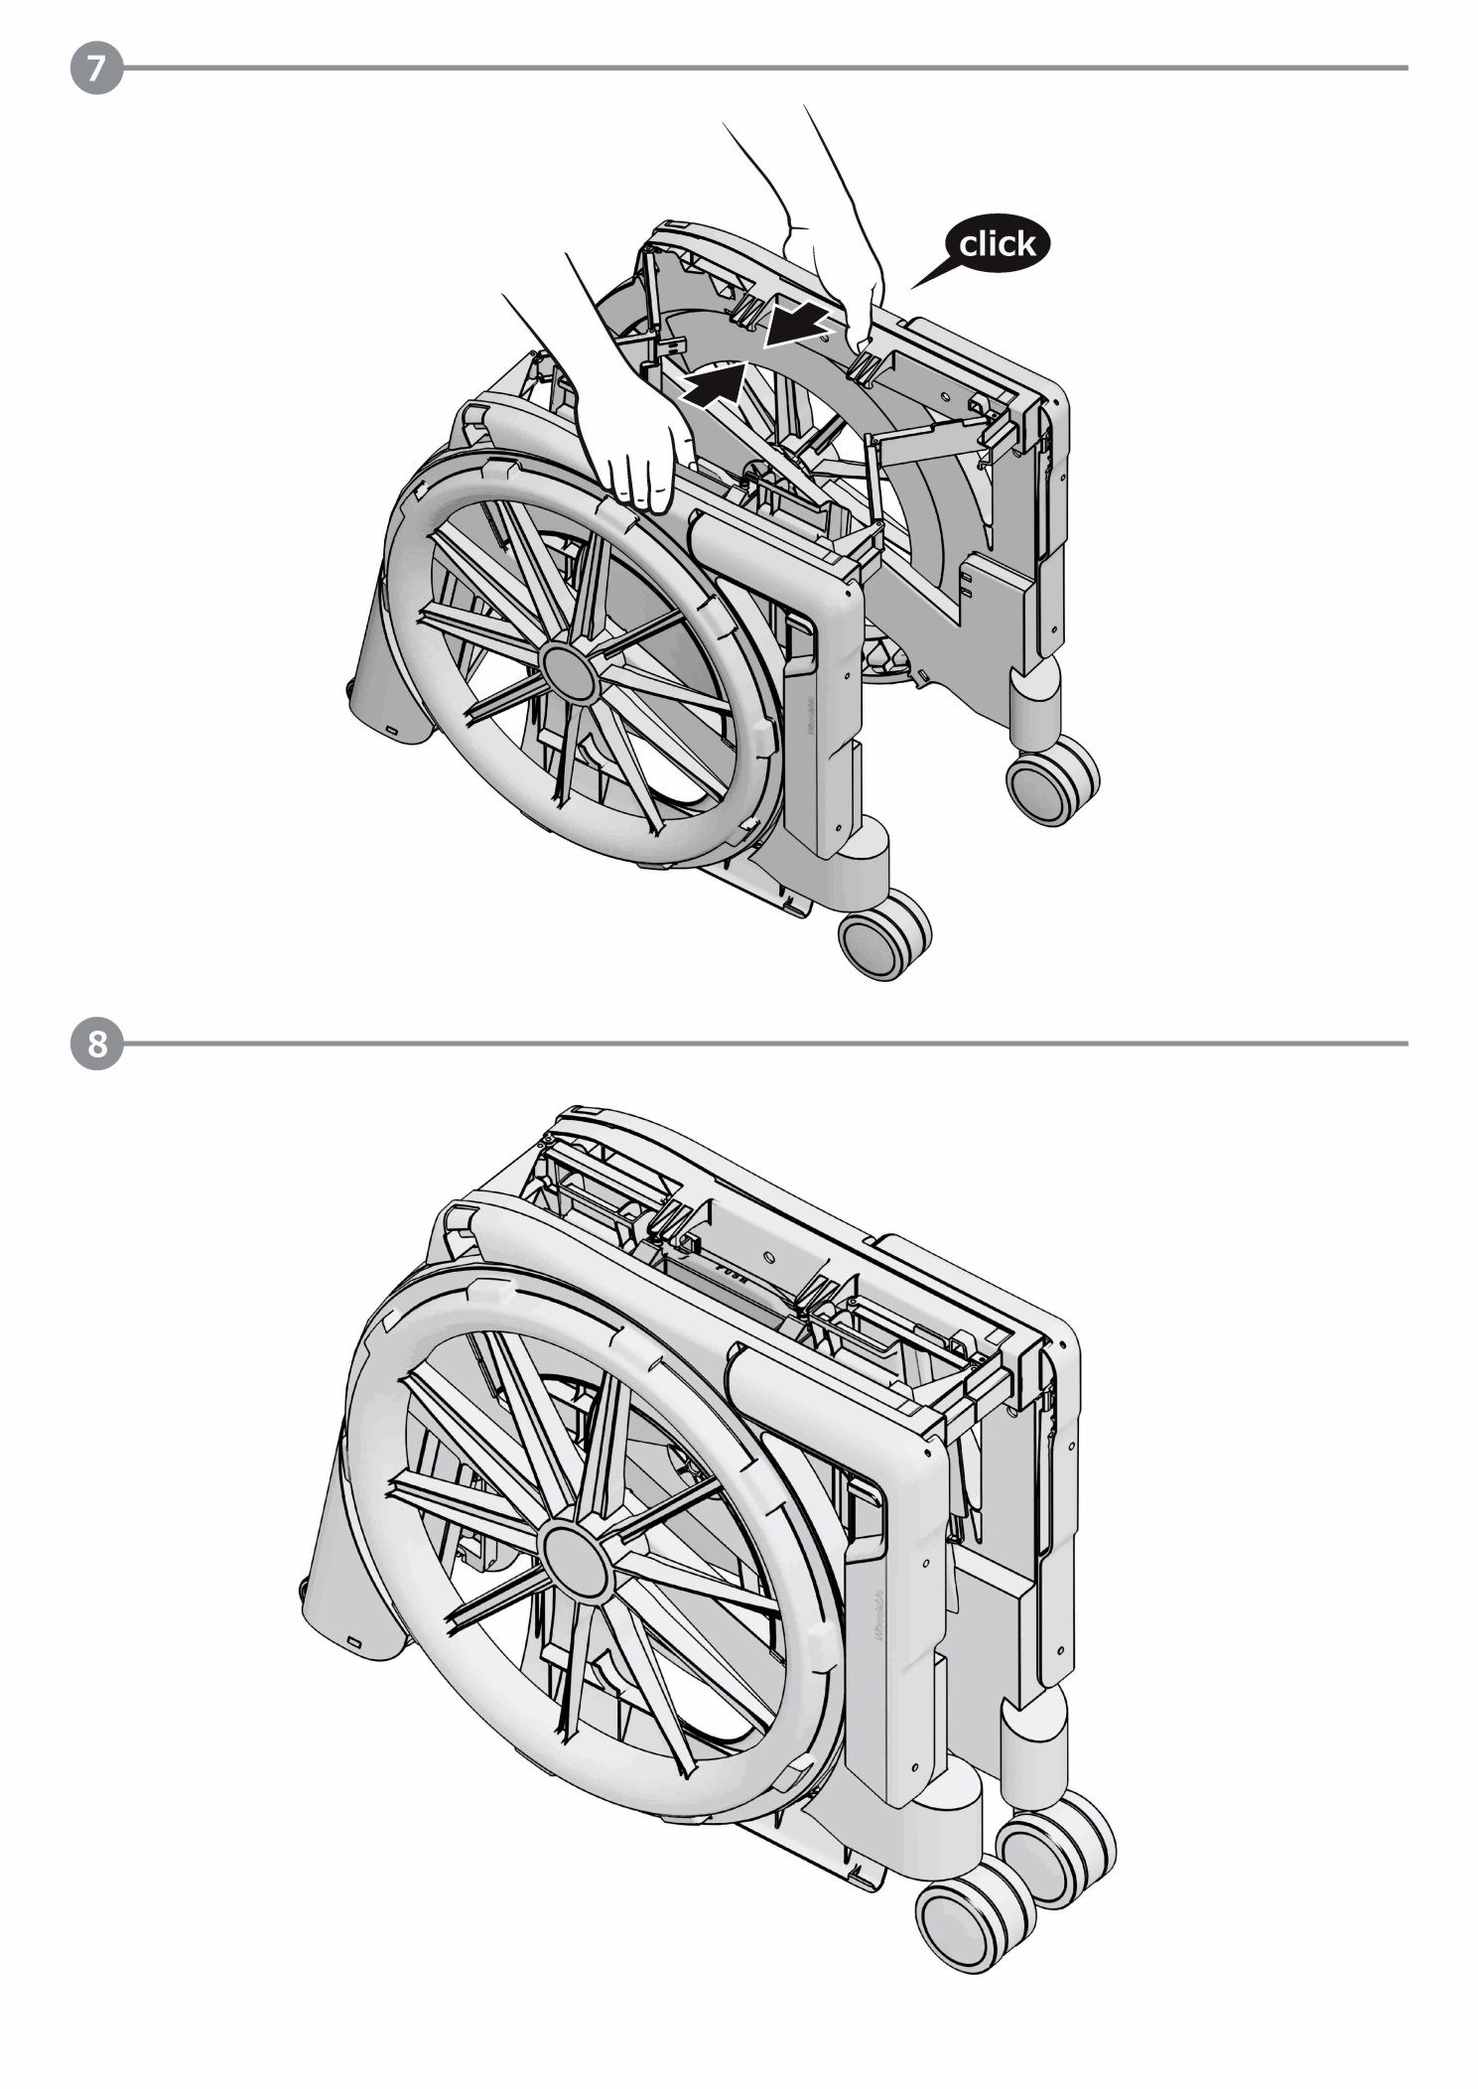

Cleaning and maintenance
The commode and shower chair can be cleaned using a mild cleaning and disinfecting agent. Simply wipe the commode and shower chair with clean water and cloth, and then wipe dry with a clean cloth.
Do not use an abrasive scouring agent or cleaner (read the product instructions!) that contain aggressive solvents (acids, thinners). Do not use stiff cleaning brushes, as these will damage the plastic surfaces or cause deposits to build up on the plastic parts and other materials.
- Never make any unauthorized modifications or conversions to the commode and shower chair. These will adversely affect the safety and function of the commode and shower chair and void the warranty and nullify the manufacturer's liability!

Warranty
Dear client,
The SEATARA Company thanks you for choosing our product.
This product warranty is valid for two years from the date of purchase.
If you experience problems with your SEATARA product or if it is damaged, please contact the store you purchased it from.
Warning! Please read the user manual and warnings in this document before using this product.
To activate the warranty, you have the following options:
- Complete the attached customer information form and send it to us, together with a copy of the purchase receipt.
- Fill out the warranty form (also available on www.seatara.com)

First name
Last Name
Address
City
State
Country
Email
Product serial number
Place of purchase (Company/Retailer name)
Purchase date

The product comes with a user manual that provides instructions on how to assemble and fold it. Please make sure you understand the instructions. If necessary, refer to the SEATARA website or contact one of SEATARA's retailers for further assistance.
Note that warning labels are affixed to the product to alert you to incorrect use.
We guarantee the integrity and functioning of all plastic and metal parts.
In the event of a warranty claim, the warranty is valid only when a filled customer information form (found at the end of this user manual) and a proof of purchase (i.e., a receipt) are provided.
This warranty does not apply to the product’s textile and sponge parts, upholstery, or surfaces (i.e., discoloration, scratches or wear and tear arising from use).
Also, the warranty does not apply to product damage resulting from unreasonable or improper use, falls from a height, or other accident.

Warnings for use
- An "indoor product" is a product that is designed for use indoors and not outside. This product is an indoor product optimized for use on paved, level floors. It is designed for use only as a commode and shower chair for toilet and for bathing.
- This product is not a substitute for a regular commode and shower chair, and is not meant to be used for prolonged sitting.
- Do not use the product to go up or down stairs.
- Do not tilt the product when a person is sitting on it.
- Do not use the product on slopes and inclines greater than 10%, or surfaces that tilt more than 5% to one side.
- The user’s weight must not exceed 100 kg.
- If there is sensitivity in the seating area, use a padded cushion.
If the product is dropped, hit, or damaged in any way that hinders the safe use of the product, stop using the product and have the product’s integrity verified by a company representative.

User Questionnaire
Please Mark X next to the most appropriate answer

Male | Female

Age
Under 18 | 18-50 | 25-120

Are you bound to a commode and shower chair?
Yes | No

If so, how many years you are using in a commode and shower chair and why?
0-2 years | 2-10 years | More than 10 years

Accident | Illness | Fatigue

How often do you use WHEELABLE?
Not at all | Once a month | Once a year

Do you have an additional commode and shower chair?
Yes | No

Are you independent or do you need a caregiver on a daily basis?
Independent | Need caregiver

Are you able to use WHEELABLE independently?
Yes | No

Have you experienced any problem related to the use of WHEELABLE?
Yes, please specify | No

Where do you store the WHEELABLE during the day?
At home | In the car | Other:

Did WHEELABLE make you change your habits?
Yes, please specify | No

How did you hear about WHEELABLE?
Assistive devices shop | Internet forum | Search through keywords | Another WHEELABLE client | Exhibition/ convention | From a professional (physiotherapist/ occupational therapist/ prostheses developer, etc.)

What would you improve in the product?

The SEATARA staff thanks you for your reply.

